**Physics 5**

Find the time period of simple pendulum 1m long where g=10m per second square.

**Explanation:**

We are given length of pendulum and the gravitational acceleration. The program calculates the time period to complete one vibration by the pendulum by using the formula of time period, as output.

**INPUT:**

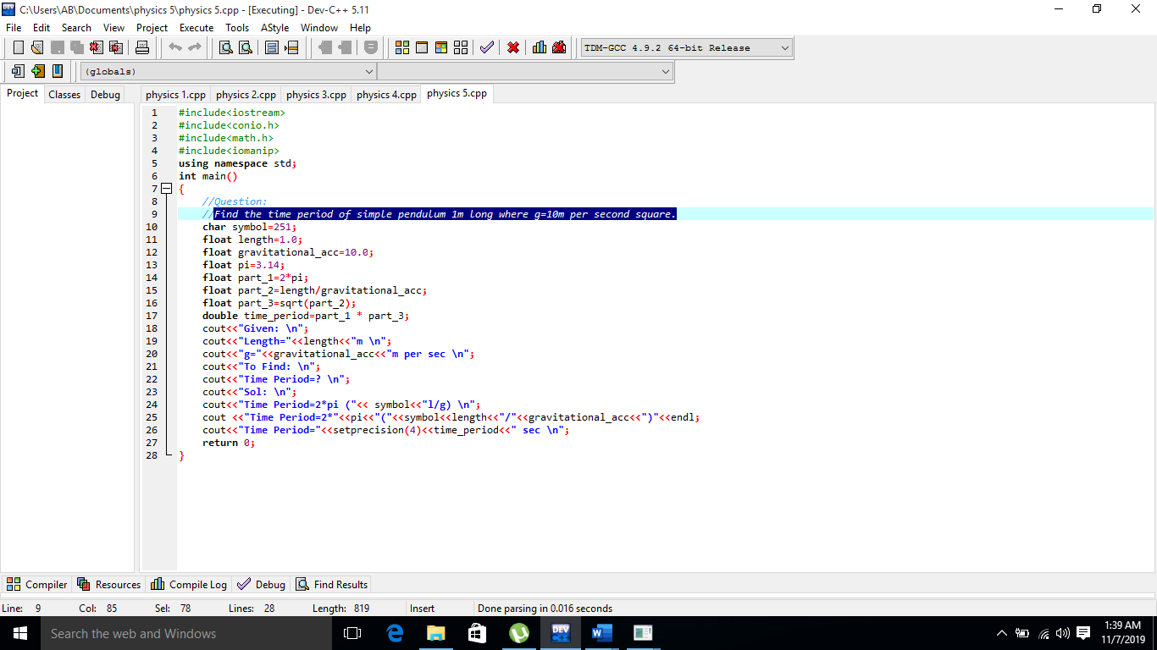

**OUTPUT:**

